Thank a Farmer (Tuesday) Friday
November 23, 2021
Ingredients:
Gallon Ziploc freezer bag
2 2/3 c. cold milk
2 pkg. (4 serving size) instant vanilla pudding mix
1 can (15 oz.) solid-pack pumpkin
1 tsp. ground cinnamon
½ tsp. ground ginger
Graham cracker crumbs
25 small cups
Scissors
1 can whipped topping
25 spoons

Directions:
Combine the milk and instant pudding in the Ziploc bag. Remove the air and zip it shut. Squeeze and knead with hands until blended for 1 minute. Add the pumpkin, cinnamon, and ginger. Remove the air and zip it shut. Squeeze and knead with hands for 2 minutes until well blended. Place ½ tsp. of graham crackers in the bottom of small cups. Cut the corner of the freezer bag and squeeze pie filling into cups. Garnish with whipped topping. Add a spoon. Eat up!
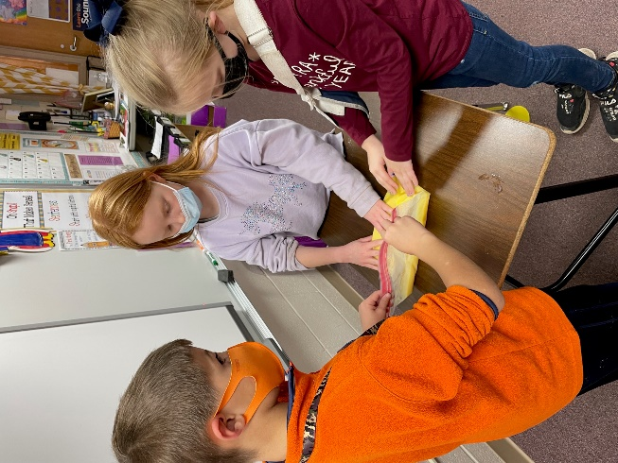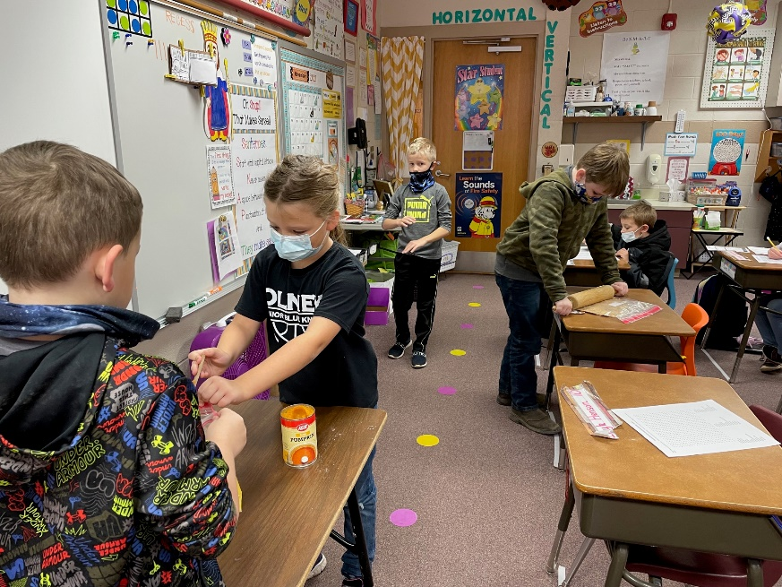

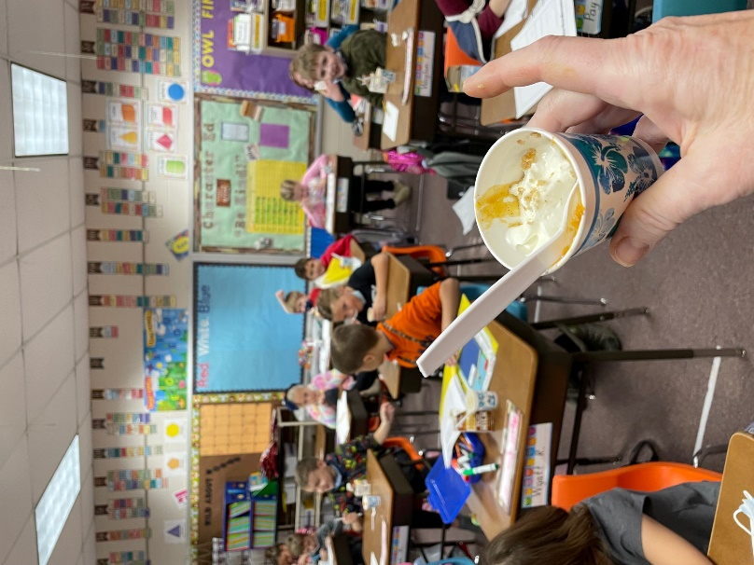

Miss Jane gave us the ingredients to make Pumpkin Pie in a Bag, so that was our snack on the last day of school before Thanksgiving. Everyone tried it, and almost all thought it was very good!

Here is the link if you want to check out the Pumpkin Ag Mag on the IL Ag in the Classroom site.
http://www.agintheclassroom.org/TeacherResources/AgMags/Pumpkin%20Ag%20Mag_11.18.21__INTERACTIVE.pdf

